Horse Show Checklist & Policies
Revised March 2011
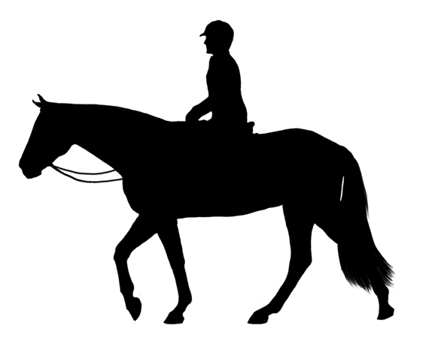

All owned competing horses should be clipped, bathed, mane pulled and shipped in a breakaway halter & cotton lead. You are expected to pack and load your horse and equipment upon departure for horse show and unpack and unload upon return. In the event you are unavailable, please make arrangements with HTF or someone else to do this.

Horse Stuff Needed
You may want to assemble and pack the following items in the horse trailers or your vehicle on Thursday prior to horse show weekends:

-Grooming box – clean brushes, clean towels, mane /tail comb, hoof pick, hoof oil, sweat scraper, Show sheen & face gel (optional) – treats / carrots

-Two (2) Water buckets, feed bucket, snaps /clips, hay net

-Pack and label feed with AM or PM and your horses name in 5 zip lock feed bags per horse including your supplements and any medications.

- We will be happy to wrap/unwrap your horse. All (clean) bell boots and wraps to be clearly labeled.

Tack/Supplies
Your equipment is your responsibility to clean, pack and transport.

All tack is to be properly cleaned and oiled. If you are leasing a horse for competition, it is possible most of the equipment will be provided and shipped for you. Please coordinate with horse owner to ensure these items are included.

- Saddles – Dressage & Jump - with leathers and irons, saddle cover
- Bridles – Dressage & Jump, legal dressage bit,) clean bits with steel wool pad
- Martingale - cannot be used while in under saddle or dressage classes -only over fences
- Clean white contour AND white, square saddle pads for show, schooling pads are your choice (clean)
- Girth
- Shampoo, crème rinse, wash bucket
- People / horse first aid kid and supplies, any medications you or horse require.
- Leather hole punch
- Stall card (per horse) containing local Emergency contact information – local hotel, etc.
- Clean sheets and / or blankets as needed
- Clips/hooks – double ended snaps – tack hooks – bridle / saddle rack

You may bring your own, but generally one item of each is to be packed for the barn to share:
Hose, stall rake, muck bucket, hammer, rope, broom, box fan, electric cord, mounting block, longeline, longe whip, side reins, spurs, dressage whip, crops, bats, spats (for schooling only), safety vests (X-Country)

People Stuff
- Breeches, jodphurs – if your child rides in jodphurs, include garter straps and bottom elastic straps (below paddock boots)
- Dressage dress shirt – ratcatcher show shirt, jackets – stock tie
- Belt, pony tail ties (binders) and ribbons (kids)
- Helmet with safety harness
- Tall Boots (for 12 & up riders), Paddock boots – clean and polished
- Black gloves
- Hair net, bobby pins, hair spray
- Rain gear
- You’ll want to have food, snacks, drinks, ice and chairs. We may plan a cookout for Friday and eat together at a restaurant Saturday, so check in with other parents for plans.

POLICIES/INFO

- Horse owners: bring a copy of current coggins test (MANDATORY) and keep in your possession.

- Coaching fees – as of 5/1/11, Friday coaching $75, Saturday and Sunday $85.00 per day – per rider. We are available for schooling after arrival and set up Friday and we strongly recommend that you school with us then. If you choose not to school, you will still be charged for the day. Arrangements for longeing or schooling can be made in advance if you or your rider cannot be present to school at this time. Single class (i.e. leadline or walk) coaching $25.

- Shipping Fees – as of 5/1/11, Fannin Hill Farm $85, SEC $95 round trip per horse, per event. Due to the VARYING COST OF FUEL, shipping prices are subject to change without notice, so please check with Bonnie.

- Additional Fees:
Hay/grain - $5/day charge per horse

Campsite/ tack room/feed room fees will be divided equally between competing students.

Clipping/trimming/bathing – time permitted, if requested available at extra charge

If your medical or emergency information has changed, please update before departure.

Please be on time, early if possible, so you or your child is ready before their classes. Horse events are about having a good time and promoting good sportsmanship!

Once your horse is set up and your equipment is unloaded, you may go to the show office to pick up your number and schedule. The office staff is very helpful in answering questions and explaining how the show will run. We will advise you of our Friday schooling schedule. Generally on competition days, you need to be tacked and ready to warm up, finding your coach 30 minutes prior to your ride time.

If you are unfamiliar with any fees or policies, please refer to www.happytalkfarm.com under the link Forms then “Bill of Fare”

We will be happy to email you an itemized invoice following the event.
Encourage everyone to help each other and interact at the show. Let’s work together to make successful showing experiences!

